Experiment-2
Name: -J pranitha Regno: -192472073
Course Code: -MLA0305 Slot-B

Title
Implementation of Markov Decision Process for Reinforcement Learning

Aim
To understand and implement a Markov Decision Process (MDP) by defining its components—states, actions, transition probabilities, rewards, and discount factor— and to demonstrate how an agent interacts with an environment.

Theory
A Markov Decision Process (MDP) is a mathematical framework used to model sequential decision-making problems in Reinforcement Learning. An MDP is represented as: where:
- S → Set of states
- A → Set of actions
- P → Transition probability
- R → Reward function
- γ (Gamma) → Discount factor
The agent observes the current state, selects an action, receives a reward, and moves to the next state.
The Markov property means that the next state depends only on the current state and current action, not on the complete history.

Procedure
- Define the Reinforcement Learning environment.
- Identify the set of states.
- Define the possible actions available to the agent.
- Define the transition probabilities between states.
- Define the reward function for each state-action transition.
- Select an appropriate discount factor (γ).
- Initialize the MDP.
- Start the agent from an initial state.
- Select an action from the available action set.
- Apply the action to the environment.
- Observe the next state and corresponding reward.
- Repeat the process until the terminal state is reached.
- Display the state transitions, actions, and rewards.
- Calculate the total/discounted reward obtained by the agent.
- Analyze the MDP and verify the Markov decision-making process.

VISUALIZATIONS

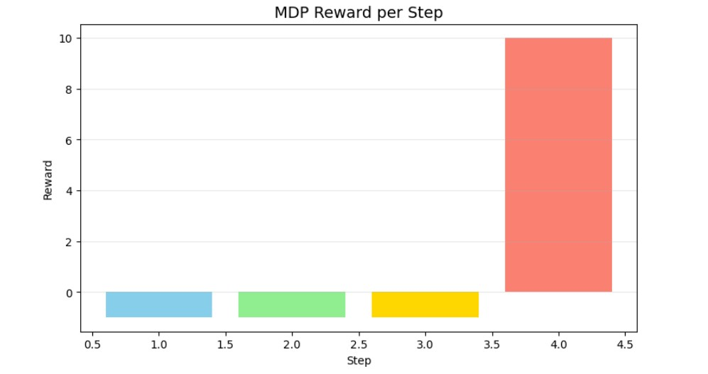

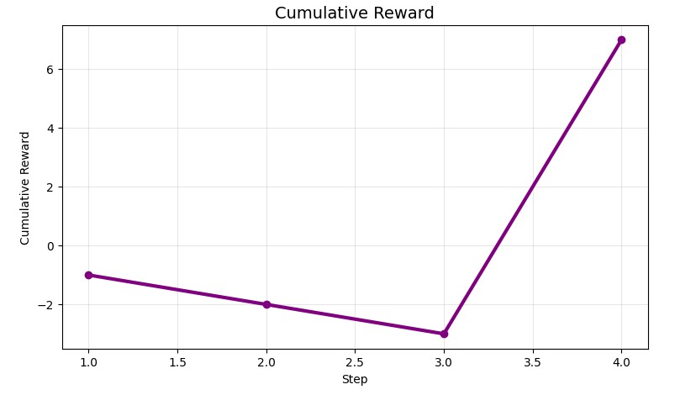

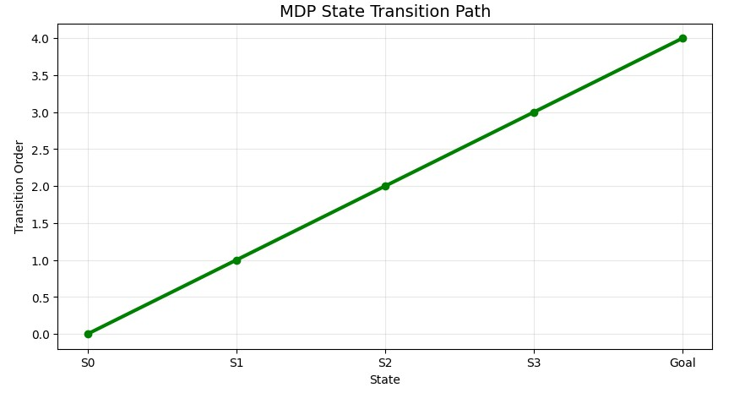

Component | Example
States | S0, S1, S2, S3, Goal
Actions | Up, Down, Left, Right
Transition | Current state → Next state
Reward | +10 for reaching Goal, -1 for an invalid/move action
Discount Factor | γ = 0.9
Initial State | S0
Terminal State | Goal

Current State | Action | Next State | Reward
S0 | Right | S1 | -1
S1 | Right | S2 | -1
S2 | Right | S3 | -1
S3 | Right | Goal | +10

Result
The MDP is successfully defined with states, actions, transition probabilities, rewards, and a discount factor. The agent successfully interacts with the environment, performs state transitions, receives rewards, and reaches the terminal state.

